KIRINYAGA UNIVERSITY
INDUSTRIAL ATTACHMENT PLACEMENT REPORT

Please complete this form and send it back PHYSICALLY or using a reliable COURIER SERVICE addressed to:

The Attachment Coordinator, School of Pure and Applied Science, Kirinyaga University
P.O. Box 143, Kerugoya.
PART I
Student’s Name: REYIA SAITOTI BENJAMIN Adm. No: CT101/G/12440/21
Course: BSC COMPUTER SCIENCE Option................................................................
Email: reyiabenjamin8@gmail.com Tel. No: 0794928779
Date: 15/05/2023 Signature: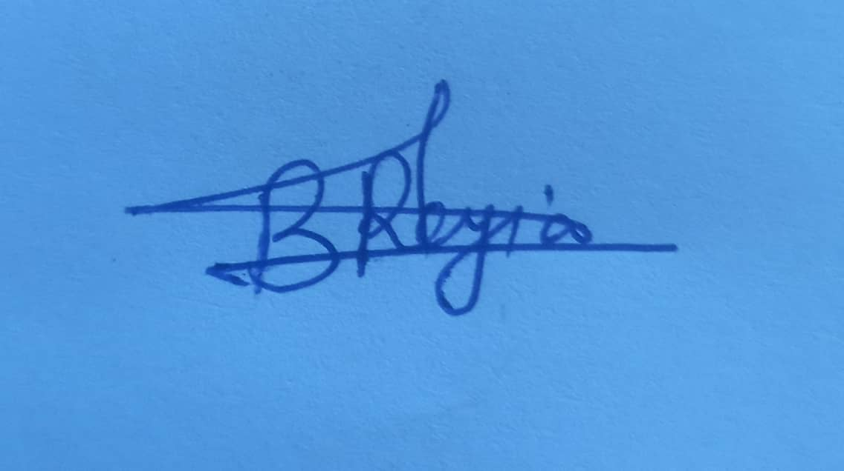

PART II
Firm(s) you are/have been attached to:
Name of firm/company: STRAIGHT UP MISSIONS
Address: P.O BOX 30 – 20502 SEKENANI Tel No: 0796018970
Email: suminmara@gmail.com
Site/Office Location: SEKENANI, MAASAI MARA
Supervisor’s/Foreman’s Name: ALVIN KABURIA Tel No: 0701093156

PART III
Attachment dates
Commencement Date: 15/05/2023 Last date of attachment: 15/08/2023 ………………………

PART IV
- Are there other students from Kirinyaga University?
If yes Name(s) Areas attached
- . ……………………………….. …………………………
- ………………………………… …………………………
- ………………………………… …………………………
- …………………………………. …………………………

- Are there other students from other Institutions?
If yes Name(s) of institution / student Areas attached
- . ……………………………….. …………………………
- ………………………………… …………………………
- ………………………………… …………………………
- …………………………………. …………………………
- Do you feel that there are some ways the Kirinyaga University can assist you to make the attachment more successful?
Am good and the institution is doing all the necessary.
- Any other comments?
No comment
Signed: Date: 15/05/2023
Note: This form together with the map of the area should be submitted on or before 10th June 2023
ROUTE MAP (WITH LAND MARKS)
NB: Attach a Google Map
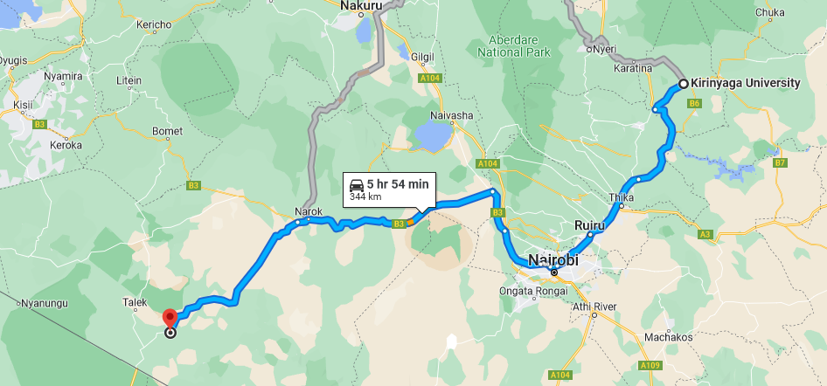

Name: REYIA SAITOTI BENJAMIN Admission No: CT101/G/12440/21
Course: BSC COMPUTER SCIENCE Option...............................................................
Tel No: 0794928779 Email: reyiabenjamin8@gmail.com
Date: 15/05/2023 Signature:

